Introduction
Modern restaurants have taken leverage of AI technology to make their day-to-day activities easier. Automation, demand prediction, customer satisfaction measurement and order management are some of the main activities where AI has helped the restaurants to attract more customers, provide efficient service and be cost effective (Wei and Simay, 2023).
(Explain the rise of Food Delivery littile bit)
Food delivery service is a critical operational component for a restaurant, contributing significantly to customer reach, revenue generation, and service efficiency (Ma et al., 2021). Sometimes restaurant cannot satisfy a significant portion of their delivery orders due to shortage of products. Short Eats or Snacks is a good example for the delivery shortage, because they are fast moving compared to other products in restaurants. Products like Packages drinks/beverages such as juices for deliveries can be excess because sufficient delivery orders have not received. Even though the technologies such as AI is improved to forecast the demand, restaurant doesn’t use it often for forecast the delivery orders, which is a negative point, technology wise for restaurants. This happens because POS Systems and other management systems used by restaurants doesn’t have a feature/option to predict the demand or even if they had, it’s a static model and cannot be used for restaurant deliveries. Very few works have been done on restaurant demand forecasting, but they are not specifically done for the deliveries. Because of these reasons, a forecasting model to predict the delivery demand for restaurants is very much needed at the current times. If a restaurant be able to predict the delivery demand before, they will be able to gather required raw materials, gather required resources and put adequate staff for the delivery component. This will lead to high customer satisfaction, no more shortages or excess stocks, cost effectiveness and high efficiency.
For deliveries, restaurants should have a delivery fleet and the number of vehicles in that delivery fleet should be able to satisfy the delivery demand. In some cases, restaurants will have so many delivery orders, but they don’t have enough vehicles to make that delivery happen. On the other hand, some restaurants will have more vehicles than deliveries. Because of these two scenarios, restaurants face losses, inefficiencies, and high costs. Therefore, while predicting the number of deliveries, optimal number of vehicles required for that predicted deliveries should be determined as the restaurant delivery fleet, to ensure the high availability, efficient allocation and cost optimization.
When finding optimal number of vehicles as the delivery fleet, there are three attributes needs to be considered. Most of the restaurants has not optimized these three attributes and it causes discrepancies in the delivery fleet. Time windows is the first and most important attribute for restaurant deliveries. Since it’s food and customer expectations should be highly satisfied when the order is delivered to their doorstep. In the restaurant context, hard time windows are taken into account because of the food quality, customer satisfaction and fixed time frames. Therefore, delivery fleet should be aligned with the hard time windows of the delivery order.
Payload capacity (weight or volume) of the vehicles in the fleet should be taken as second attribute to consider because the total order capacity (weight or volume) should be matched to payload capacity (weight or volume) of the vehicle. Otherwise, the foods will be contaminated, and quality will be reduced. Therefore, according to the different types of the products in the orders, they should be packaged and stored efficiently in the vehicle and the vehicle payload capacity should be matched.
Operating Distance of vehicles is the third attribute. This attribute is equally proportional to energy of the vehicle which means the fuel consumption. Because of this, there is a specific distance constraint for every vehicle in the fleet, which leads to change the number of vehicles to satisfy the delivery demand in multiple locations.
Balancing time windows, capacities and distances with the number of vehicles is hard. Many studies have been conducted on this, but they are either focused one attribute or maximum, two attributes. But in restaurant industry, all the three attributes should be considered and balanced with number of vehicles. As mentioned before, even though the technology is developed, most of the restaurants and delivery platforms, do not utilize sufficient technology to optimize all the 3 attributes and the number of vehicles. By leveraging operations research methodologies, the optimal number of vehicles required for deliveries can be determined by incorporating constraints such as time windows, vehicle capacities, and travel distances. Through the application of advanced optimization techniques, restaurants can effectively allocate their delivery resources. This enables a more efficient response to varying delivery demands while minimizing operational costs and maximizing fleet utilization.
Since the world is moving towards sustainability these days and restaurants are adopting sustainable practices for every component of their operations. Reducing polyethene, minimizing food wastages are couple of key practices that restaurants are implementing often. But when it comes to delivery, most of the restaurants use the traditional delivery bike or the scooter, which is not an ideal sustainable practice. Delivery bikes and scooters cause considerable percentage for the urban pollution. Since the number of delivery bikes and scooters are increasing day by day, pollution causes by them, increases significantly. Therefore, restaurants should integrate sustainable option for delivery mode as well.
According to facts discussed above, a research opportunity can be identified as there are not much research done on modelling to predict restaurant deliveries, optimize delivery fleet and integrating sustainable delivery modes. In this research, we aim to develop a model that predicts restaurant delivery demand using Artificial Intelligence, determines the optimal fleet size based on the forecasted demand using operations research techniques, and analyses a sustainable delivery mode in comparison to traditional methods.
The structure of the paper is as follows. Section 2 provides an overview of the current context of restaurant deliveries, including an exploration of the technologies currently used and potential innovations for various operational processes, as well as sustainable delivery methods for the restaurant industry. In Section 3, the proposed methodology is explained, including the data collection approach, model development, and analytical techniques. Section 4 presents the results derived from the testing and execution of the model. Finally, Section 5 concludes the paper, highlighting the challenges encountered and discussing the implications for future research and practice.

Literature Review

AI in Restaurants
The restaurant sector of the hospitality business has undergone extensive research and implementation of Artificial Intelligence. (Berezina et al., 2019) indicate that other studies have investigated the potential of AI to improve the operational efficiency of restaurants. Principal applications encompass chatbots, tailored recommendation systems, voice-activated technologies, and biometric identification. These AI-driven technologies enhance consumer engagement, enable dynamic menu generation, streamline meal ordering, and allow client identification. Furthermore, robots that incorporate many applications and physical interaction skills provide a unique dining experience (Berezina et al., 2019) (Wei and Simay, 2023). The implementation of these technologies has conferred numerous benefits to restaurants, although it has also presented specific obstacles (Wei and Simay, 2023).

Restaurant Deliveries
Technological developments and the rise of meal delivery services have caused a significant change in consumer behaviour, transitioning from in-house eating to food delivery. Numerous studies have shown that this transition has both broadened the clientele for restaurants and improved overall customer satisfaction(Ma et al., 2021). This transition has positively impacted the broader economy (Auad et al., 2024). The COVID-19 pandemic, with its travel restrictions, greatly sped up this trend. Nevertheless, the relaxation of pandemic-related regulations, the preference for food delivery endures, driven by reasons including ease, accessibility, and a variety of payment methods (Ma et al., 2021).

Food Delivery Services
The provision of delivery services increases a restaurant's operating capacity. To accomplish these deliveries, restaurants frequently use third-party services like Grubhub and DoorDash. These meal delivery platforms have made significant profits because of the increased demand for restaurant delivery orders(Ma et al., 2021). Concurrently, restaurants have seen a rise in revenue from delivery services. However, the hefty commission fees charged by these delivery platforms have severely reduced the profitability of restaurant delivery operations(Collison, 2020) (Chen et al., 2019).

Own Delivery Fleet
Due to the falling profitability of food delivery services and lack of operational control on deliveries (Surutha Lakshmi L. et al., 2024), many restaurants are gradually choosing to build their own delivery fleets. This strategy enables for customisation depending on unique operating requirements and eliminates the need to share earnings with third-party providers. While operating expenses persist, they account for a decreasing fraction of total costs (Chen et al., 2019). However, a major challenge for restaurant management is deciding whether to rent or own vehicles for their delivery fleets. Both business concepts have been extensively researched. The findings mainly support the use of a rental model for restaurant delivery fleets, citing cost-effectiveness and flexibility in reacting to demand swings (Galkin et al., 2021).

Demand Prediction for Deliveries
In recent times, restaurants have begun to utilise demand forecasting methods to improve the productivity of their everyday operations. Some high-end restaurant businesses along with small, scaled restaurants have implemented artificial intelligence technologies to estimate demand in advance (Pandey et al., 2023). However, these demands forecast methods often focus on the entire restaurant rather than specific components. (Tanizaki et al., 2020) has shown that, particularly in dynamic industries such as the restaurant business, it is critical to forecast demand for individual aspects of the service separately. Demand forecasting for restaurant deliveries necessitates personalised attention to effectively predict future delivery needs.

Clustering customer locations of deliveries
Accurately forecasting demand might be difficult in the framework of a restaurant trying to maximise delivery coverage over a wide service area when orders are distributed unevenly. While places with less or less frequent orders, especially those far from the restaurant, are considered equally despite their little contribution to total demand, areas with high frequency of orders typically dominate the prediction model (Liang et al., 2023). Segmenting the service area into several zones depending on past customer location data is essential to handle this problem. Applying an unsupervised learning method—such as clustering—allows the delivery region to be reasonably divided into significant zones. Since every zone can be modelled independently and considers the trends of consumer behaviour in every area, this enables more exact demand prediction (Zhao, 2024).

Delivery Demand Prediction using Neural Networks
Neural networks have received considerable interest in recent years for their use in demand prediction models, due to their adaptability and ability to capture complex, non-linear correlations in time series data. The unpredictable dynamics of restaurant deliveries render neural networks an optimal option. These models are especially proficient in managing long-term dependencies in the data, hence improving prediction accuracy. Moreover, neural networks' capacity to process delivery data as sequential inputs enables them to adeptly learn from temporal patterns, resulting in a more accurate and adaptable model for real-world applications (Khurana and Kaul, 2022).

Delivery Fleet Size Optimization
The delivery fleet size of a restaurant is a critical metric, as failure to optimise it may result in operational losses (Labib and Watfa, 2023). A restaurant encounters two real-life challenges: an excess of vehicles relative to delivery demand and a shortage of vehicles compared to delivery demand (Auad et al., 2024). The issues get worse when a restaurant leases vehicles for its delivery fleet, as management must determine the ideal number of vehicles required for rental. For that, three attributes needed to be taken into account during the optimization: time windows of the order, capacity of the vehicle and maximum distance of the vehicle (Hsu et al., 2007).

Time Windows of the Delivery
In the context of restaurant deliveries, Hard Time Windows are defined by predefined time periods between order generation and order delivery. Adherence to these time limitations is critical, as failing to do so may result in consumer unhappiness and customer loss (Surutha Lakshmi L. et al., 2024). Given the perishable nature of restaurant food and the need to preserve its quality until it reaches the customer, careful adherence to these time frames is essential. As a result, the delivery fleet must have enough vehicles to efficiently meet these time limitations and assure on-time delivery (Hsu and Chen, 2014).

Capacity of the Vehicle
The delivery vehicle’s capacity is a crucial consideration when several deliveries are planned within a designated time frame and can be managed along a single route with one vehicle. Utilising a single vehicle for the delivery process is feasible if its capacity adequately meets the total demand of all deliveries along the route while complying with the designated time limits (Morito et al., 2016). Thus, integrating vehicle capacity limitations into the delivery fleet optimisation is crucial for improving operating efficiency and guaranteeing prompt order fulfilment.

Maximum Distance of Vehicle
The maximum distance a vehicle can travel is directly proportional to its energy capacity, which is determined by fuel consumption in conventional vehicles or battery consumption in electric vehicles (Sun et al., 2021). Consequently, it is essential to calculate an average maximum distance prior to initiating optimization processes. In fleet optimisation, this maximum distance must include the trip from the restaurant to the consumers and the return journey to the restaurant. The maximum distance a vehicle can travel is a crucial element to consider in the optimisation of delivery fleets (Peng and Wang, 2009).

Sustainable Delivery Modes
Since sustainability is a major worldwide concern, businesses in many different industries—including hospitality—are using sustainable methods more and more. Particularly the restaurant industry has put policies including waste minimisation, recycling promotion, and environmentally friendly packaging use into effect (Higgins-Desbiolles et al., 2019). Still, the sustainability of food delivery services done by third parties and restaurants is mostly neglected since typical delivery vehicles still depend on traditional scooters and motorbikes. Especially in high-frequency metropolitan regions, these forms of mobility greatly add to pollution. Consequently, switching to sustainable delivery solutions is essential to reduce environmental effect and match the restaurant business with more general sustainability goals (Sunarso and Wibowo, 2023).

E-Bikes
E-bikes have gathered considerable attention in modern society due to their ease and energy efficiency, which aid in reducing pollution by eradicating fuel usage. Many governments actively support for the adoption of e-bikes by individuals and enterprises as a component of their sustainability projects. Given that most restaurants use traditional motorcycles or scooters for deliveries, switching to e-bikes is a realistic and ecologically responsible option. The elimination of fuel expenditures can result in significant financial savings for restaurants, making e-bikes an economically viable option. As noted in Section 2.2.2, renting vehicles for delivery services is a better option for restaurants than acquiring them. Many countries have established e-bike rental firms that provide daily or monthly leasing choices, thereby boosting the adoption of this sustainable means of transport. Thus, e-bikes are a practical and appropriate choice for restaurants looking to improve their sustainability efforts (Gouda, 2024).

Research Methodology
In this section, we describe how the data is collected for restaurant deliveries, data pre-processing for the collected dataset, model development to predict the number of deliveries and give an optimal fleet, and the analysis integrating E-Bikes to restaurant deliveries compared to traditional bikes and scooters using derived demand and optimized fleet from the model development.

Data Collection
The data for this study was obtained from Kaggle, specifically the Food Delivery Dataset by (Malik, 2022). The dataset, available at https://www.kaggle.com/datasets/gauravmalik26/food-delivery-dataset, contains 45593 detailed records of daily food delivery transactions, including order times, delivery duration, customer ratings, and restaurant details happened from 1st of March 2022 to 6th of April 2022. This dataset was selected due to its comprehensive nature and relevance to analysing food delivery patterns.
Before analysis, data preprocessing steps such as handling missing values, data quality issues, data type issues, location processing, scaling and creating sequences were performed to ensure data consistency.
Below data from the dataset will be used for the model creation.
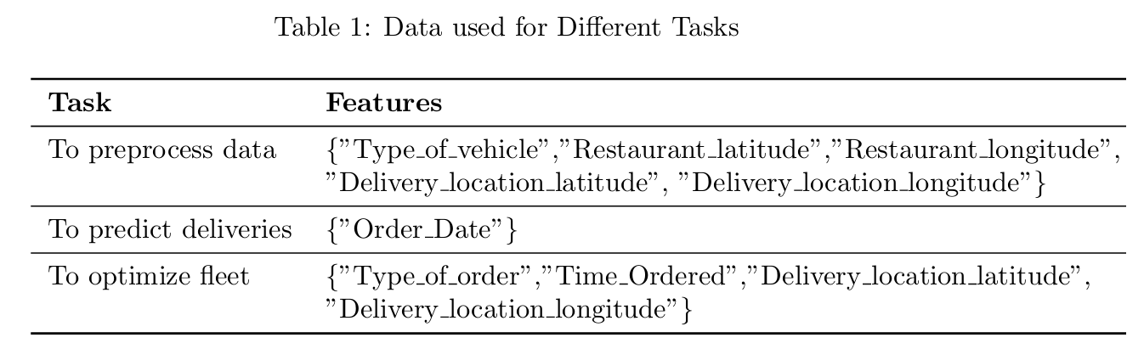

Data Preprocessing

Predefined Values
Before starting to analyse the data, we declare Start Date and End Date of the dataset and Start time and End time for each day. This could be important when we are trying to get a prediction for separate time frame, for example, deliveries between 5pm – 9pm for a future date, or to get a prediction using a specific date range like using 25 days before Christmas which could identify the seasonality well. If there is a not normal scenario happening in the country, restaurants could use this part to get data from separate dates and separate times.

Handling Data Quality Issues and Filtering Data
Data Quality Issues such as extra blanks on the data are removed and null values containing rows are dropped to avoid any discrepancies. We convert Order Date and Order Time Data as Date and Time Type variables to filter the data within the predefined Start and End Date and Times mentioned in 3.2.1 section. In the dataset, there are some records with “0.0” as latitudes and longitudes which are bad data. We need to remove those records. And we need to choose deliveries with values “scooter” and “motorcycle” in the “Type of Vehicles” column as we are focused to analyse integrating E-Bikes comparing with traditional motorcycle and scooter.

Restaurant Location processing
This dataset contains orders from many different restaurants. Since we are focused modelling on one restaurant, we need to re-process the records again from assuming the delivery happened from one restaurant. Therefore, we need to do a separate analysis to find out the counts from each restaurant in the dataset and sort the count in descending order. From the output, we can find out latitudes and longitudes of the restaurants which have the highest order count and within specific latitude and longitude range. And assume the restaurant location is the mean of latitude and longitude. Now we can filter our main dataset by choosing only restaurants which has the highest counts.

Model Development
Through extensive exploration of studies on various industries, we have identified the best and most promising algorithms and methods to use in this model development. They will be discussed in the next sub sections.

K-Means Clustering
As discussed in Section 2.3.1, customer locations needed to be separated into different zones or in this case, clusters, so we can forecast the delivery demand for each customer cluster and allocate delivery fleet according to the predicted demand of the cluster. This is helpful for restaurants to identify what zone of their delivery area has more orders or less orders and how the fleet adjustments should be happened according to that. (Li, 2013) suggests that K-Means clustering is the ideal algorithm when it comes to Customer Segmentation. We adopt it and adjust to restaurant delivery scenario based on the customer locations as below to find out the optimal number of number of clusters and from that optimal number of clusters, which cluster the delivery fall into.
$$n=Total number of cutomer delivery locations$$
$$K=Number of clusters (optimal number selected using silhouette scores)$$
$$X=x_{1},x_{2},…,x_{n}=Set of delivery locations\left(latitude,longitude pairs\right)$$
$$C=\{c_{1},c_{2},…,c_{K}\}=Centroids of each cluster$$
$$Each delivery location x_{i} is assigned to the closest cluster c_{k} by minimizing the total squared$$
$distance$
$$J=\sum_{i=1}^{n}{\sum_{k=1}^{K}{w_{ik}{‖x_{i}-c_{k}‖}^{2}}}$$
$$J=Total clustering cost \left(sum of squared distances\right)$$
$$w_{ik}=1 if delivery location x_{i} is assigned to cluster k,otherwise 0$$
$${\left\|x_{i}-c_{k}\right\|}^{2} =Euclidean distance between delivery location x_{i} and cluster center c_{k}$$
$$Optimization Steps:$$
$$1.Initialize K restaurant delivery zones randomly.$$
$$2.Assign each delivery to the closest zone.$$
$$3.Update the zone^{'}s center based on assigned deliveries:$$
$$c_{k}=\frac{1}{\left|S_{k}\right|}\sum_{x_{i}∈S_{k}}{x_{i}}$$
$$where S_{k} is the set of assigned deliveries for cluster k.$$
$$4.Repeat until deliveries no longer change clusters significantly.$$

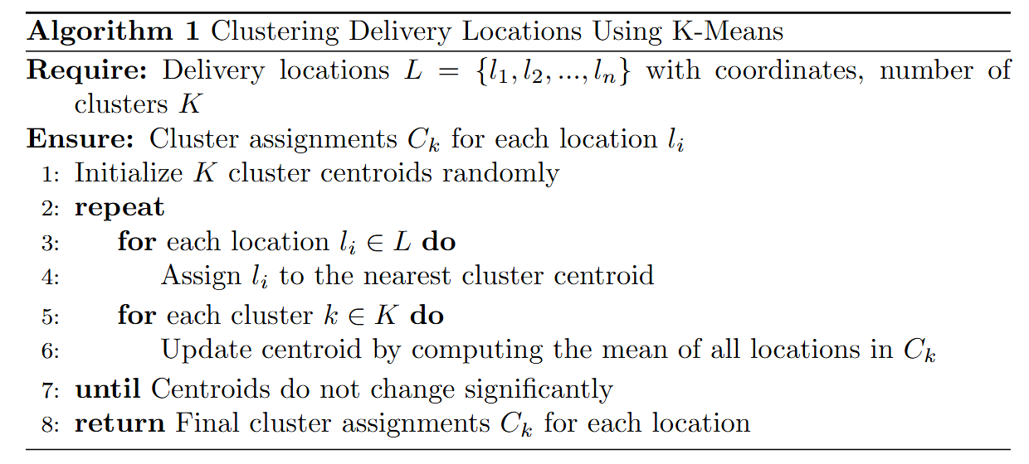
To find the optimal number of clusters we run the above algorithm for multiple values K = {2, 3, 4, 5, …10} and evaluate the silhouette coefficient for each K. Starting K Value and Ending K value might be managerial decision according to the needs and wants of the restaurant business. K value which holds the maximum silhouette coefficient will be considered as the optimal number of the clusters and each delivery will be assigned to a cluster.

Delivery Prediction using LSTM
After clustering the deliveries based on customer locations, we can predict the demand for each cluster separately. So, the model can dynamically allocate fleet based on the number of deliveries for each cluster. This helps restaurant to cater their demand for different zones(clusters) of their delivery area differently. As mentioned in section 2.3.2, Neural Networks are the ideal solution for this time series problem. Because of the dynamic nature of restaurants and non-linear patterns of demand, LSTM, a type of a Recurrent Neural Network can be used to predict the number of deliveries for a certain time for a restaurant (Schmidt et al., 2022). Even though LSTM needs High Computation, Seasonal Trends in restaurants can be captured accurately due to the better capacity of long-term memory (Khurana and Kaul, 2022). For our model, we have adopted LSTM and adjusted to predict the future deliveries as mathematically explained below.
$At each time step t, given historical deliveries x_{t} and hidden state h_{t},the LSTM updates$ $as follows:$
$$Forget Past Information,{ f}_{t}=σ\left(W_{f}x_{t}+U_{f}h_{t-1}+b_{f}\right)$$
$$Decide What to Remember, \begin{aligned}i_{t}=σ\left(W_{i}x_{t}+U_{i}h_{t-1}+b_{i}\right) \\ {\overline{c}}_{t}=tanh\left(W_{c}x_{t}+U_{c}h_{t-1}+b_{c}\right)\end{aligned}$$
$$Update Memory State, c_{t}=f_{t}⊙c_{t-1}+i_{t}⊙{\overline{c}}_{t}$$
$$Generate Prediction\text{, } \begin{aligned}o_{t}=σ\left(W_{o}x_{t}+U_{o}h_{t-1}+b_{o}\right) \\ h_{t}=o_{t}⊙tanh\left(c_{t}\right)\end{aligned}$$
$$where:- \\ x_{t}=Number of deliveries on day t$$
$$h_{t}=Hidden state representing delivery trends$$
$$c_{t}=Cell state storing long-term demand patterns$$
$$W,U,b=Trainable weight matrices and biases$$
$$σ\left(⋅\right)=Sigmoid activation function$$
$$⊙=Element-wise multiplication$$

Moving Window Approach
Since we are ha

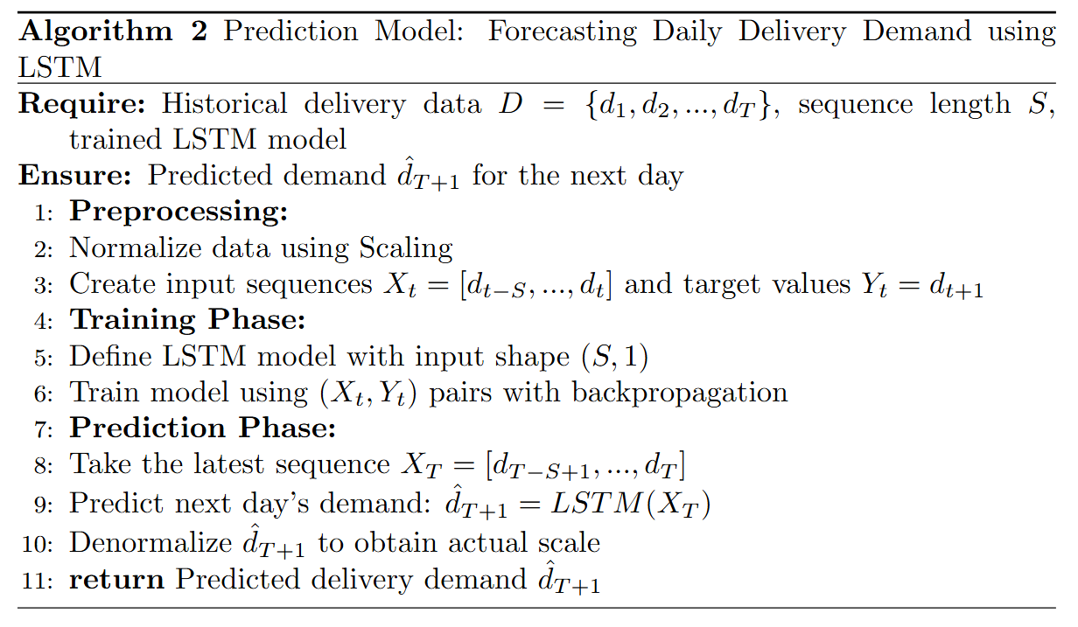
$$The model is trained to minimize Mean Squared Error\left(MSE\right) :$$
$$L=\frac{1}{N}\sum_{t=1}^{N}{{(y_{t}-{\overset{^}{y}}_{t})}^{2}}$$
$$where:-$$
$$y_{t}=Actual deliveries on day t$$
$${\overset{^}{y}}_{t}=Predicted deliveries$$
$$N=Total number of days$$
$$The model is evaluated using Pearson^{'}s Correlation Coefficient\left(r\right):$$
$$r=\frac{\sum_{t=1}^{N}{\left(y_{t}-\overline{y}\right)}\left({\overset{{}^{}}{y}}_{t}-\overset{―}{\overset{{}^{}}{y}}\right)}{\sqrt{\sum_{t=1}^{N}{{\left(y_{t}-\overline{y}\right)}^{2}}}\sqrt{\sum_{t=1}^{N}{{\left({\overset{{}^{}}{y}}_{t}-\overset{―}{\overset{{}^{}}{y}}\right)}^{2}}}}$$
$$where:-\text{\backslash (}y_{t}=\text{\backslash )}Actualdeliveriesonday\text{\backslash (}t\text{\backslash )}-\text{\backslash (}{\overset{^}{y}}_{t}=\text{\backslash )}Predicteddeliveries-\text{\backslash (}\overline{y}=\text{\backslash )}Meanofactualdeliveries-\text{\backslash (}\overset{―}{\overset{^}{y}}=\text{\backslash )}Meanofpredicteddeliveries-\text{\backslash (}N=\text{\backslash )}Totalnumberofdays$$

Synthetic Location Data Generation
$$Since actual future orders are unknown,we generate synthetic delivery locations based on$$
$past trends.$
$$A new delivery location x^{'} is sampled from a multi variate normal distribution centered$$
$$around the cluster^{'}s past delivery points:$$
$$x^{'}∼N\left(μ,Σ\right)$$
$$where:-$$
$$μ=\left(μ_{x},μ_{y}\right)=Mean coordinates of past delivery locations in the cluster$$
$$Σ=Spread\left(covariance matrix defining variation in locations\right)$$
$$To mix real and synthetic data,we use a blending factor α:$$
$$X_{\text{final }}=αX_{\text{real }}+\left(1-α\right)X_{\text{synthetic }}$$
$$where:-$$
$$X_{\text{real }}=Sampled historical delivery locations$$
$$X_{\text{synthetic }}=Artificially generated delivery points$$
$$α=\frac{Total Deliveries for the Cluster}{Total Deliveries of the Restaurant}$$

Vehicle Routing Optimization
$$Once predicted deliveries are available, we determine the best way to assign orders to drivers$$
$$and minimize travel costs.$$
$$Mathematical Formulation$$
$$We define:-$$
$$N=Set of delivery locations$$
$$V=Fleet of delivery vehicles$$
$$d_{ij}=Distance between delivery locations i and j$$
$$t_{ij}=Travel time from i to j$$
$$x_{ijv}=1 if vehicle v travels from i to j ,otherwise 0$$
$$Q_{v}=Capacity of vehicle v$$
$$C_{v}=Maximum allowed travel distance per vehicle$$

$$Objective:$$
$$Minimize Total Distance$$
$$min\sum_{v∈V}{\sum_{i∈N}{\sum_{j∈N}{d_{ij}x_{ijv}}}}$$

$$Constraints:$$
$$1.Each delivery must be assigned exactly once$$
$$\sum_{v∈V}{\sum_{j∈N}{x_{ijv}=1, ∀i∈N}}$$
$$2.Vehicles must return to the restaurant \left(flow conservation\right)$$
$$\sum_{j∈N}{x_{ijv}}=\sum_{j∈N}{x_{jiv}},∀i∈N, v∈V$$
$$3.Vehicles cannot exceed their load limit$$
$$\sum_{i∈N}{q_{i}x_{ijv}}≤Q_{v}, ∀∈V$$
$$4.Deliveries must be completed within allowed time windows$$
$$T_{i}≤t_{i}≤T_{j}, ∀i,j∈N$$
$$5.Vehicle trips cannot exceed maximum allowed distance$$
$$\sum_{i∈N}{\sum_{j∈N}{d_{ij}x_{ijv}}}≤C_{v}, ∀v∈V$$

